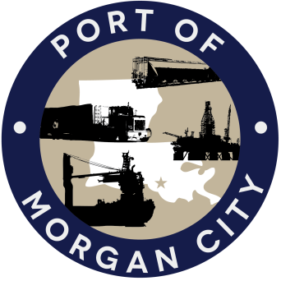

AGENDA

MORGAN CITY HARBOR AND TERMINAL DISTRICT
Regular Meeting of May 8, 2017 – 5:00 p.m. – 7327 Highway 182

1. Call to Order and Roll Call

2. Invocation and Pledge of Allegiance

3. Minutes
A. Regular Meeting of April 10, 2017

4. Finance Report
A. Presentation and discussion of financial reports for April 2017 – Deborah Garber
B. Invoices

5. Guest(s)/Public Comment
A. United States Coast Guard
B. Corps of Engineers, New Orleans District

6. Raymond “Mac” Wade - Executive Director’s Report
A. Consultant – Michael Knobloch, Knobloch Professional Services, LLC
B. Consultant – Clay Breaud, Providence/GSE
C. Consultant – Michael Lowe, GIS Engineering, LLC
D. Cindy Cutrera, Manager of Economic Development

7. Gerard Bourgeois - Legal Report

8. New Business
A. Discussion and any action on Insurance Renewal Quotes from Paul’s Agency, LLC
B. Discussion and any action Adoption of millage rate(s) for tax year 2017
C. Discussion and action on agreement for vessel captain services of L.R. Services, LLC

9. Old Business
A. Discussion and any action on leasing, improvements, maintenance and repairs to facility(ies), including Coast Guard lease(s)
B. Discussion and any action regarding the U.S. Department of Homeland Security grant program, including request for proposals, bids, purchases, project management, generators, computer data system and NOAA ports system(s)
C. Discussion and any action on Government Operations and Emergency Center including bids, purchases, payments, leasing and Facility Planning and Control
D. Discussion and any action on Atchafalaya River Channel dredging and sediment management, including:
i) agreement for services of Cassidy & Associates, Inc, principally through Charles Brittingham for assistance with dredging and sediment management issues;
ii) retention of Greenwood Marine Management, Inc., principally through Dan Duplantis for services related to District’s dredge project;
iii) agreement with Incat Crowther for design and consultation services related to dredge and sediment management issues;
iv) proposal from K2 Dronotics to provide alternatives or comment to the special purpose dredge;
v) resolution in favor of construction of a dredge in the event that private companies do not respond favorably to request to locate in Morgan City area a special purpose dredge capable of moving 11,000 cubic yards of material in the Atchafalaya Bar Channel per hour;
vi) Day to day tasks for the dredge project itself, including any other equipment purchases, reports, survey services, consulting services, permitting and economic study(ies); and
vii) Discussion and any action on disposal agreement with C.M. Thibodaux Company, Ltd.
E. Discussion and any action on 2016 flood fight.

10. Adjournment

In accordance with the Americans with Disabilities Act, if you need special assistance, please contact Tori Henry at 985-384-0850, describing the assistance that is necessary.

